Internal Audit Report IA-2026-04
Kestrel Ridge Wind Farm – ISO 45001 / ISO 14001
Hannah Weber · 22 May 2026 · IA-2026-04
Item | Details
Date | 12 May 2026
Auditor | Hannah Weber
Auditees | Ben Okoye, Stuart Laidlaw (Highline), Sara Lindgren
Scope | Operations, contractor management, emergency preparedness, environmental monitoring

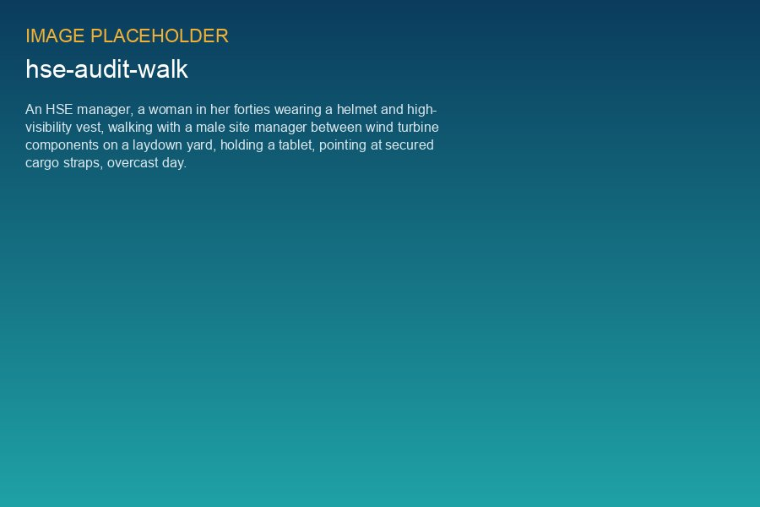
Site walk during the audit

1. Overall assessment
Kestrel Ridge is a well-run site with an open safety culture. The T-07 gearbox exchange in February was managed safely, and lessons were documented. Two minor non-conformities and three observations were raised.

2. Findings
No. | Type | Finding | Action | Due
1 | Minor NC | Two rescue kits (T-09, T-16) past their 12-month inspection date by 3 weeks | Inspect, add to Highline monthly checklist | 2026-05-31
2 | Minor NC | COSHH assessment for new gearbox oil additive (trial on T-04, T-09, T-12) not available | Obtain SDS, complete assessment | 2026-06-15
3 | Observation | Spill kit at substation partially used and not refilled | Refill, add to monthly inspection | 2026-05-20
4 | Observation | Ice throw warning sign at stile 2 faded | Replace sign before winter | 2026-09-30
5 | Observation | Working alone check-in calls logged inconsistently on weekends | Remind control room and Highline | 2026-05-31

3. Good practice
- Daily start-of-work briefing including Highline and Weyland staff.
- Bird carcass monitoring well documented.
- Clear records of ice stops and restarts in winter 2025/26.
Status 1 October 2026: all actions closed. Finding 4 (sign) closed on 24 September.

